**3/3a/3x in 5G**

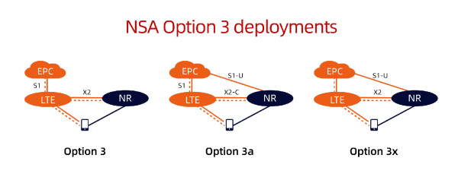

**3/3a/3x refers to different carrier aggregation (CA) configurations. Carrier aggregation is a technology that combines multiple frequency bands to increase the data rate and capacity of the network. Here’s a brief explanation of each:**

1. **3 Carrier Aggregation (3CA): This configuration aggregates three different frequency carriers. By combining these carriers, the network can offer higher data rates and improved performance compared to using a single carrier. This is often used to increase the throughput in areas with high data demand.**
2. **3a Carrier Aggregation (3aCA): This is a specific form of 3CA where at least one of the aggregated carriers is in a higher frequency band (such as millimeter wave or mmWave) and the others are in lower frequency bands (such as sub-6 GHz). The higher frequency bands provide very high data rates, while the lower frequency bands ensure broader coverage and better signal penetration.**
3. **3x Carrier Aggregation (3xCA): Similar to 3CA, but the ‘x’ typically indicates the use of three carriers from the same frequency band. This configuration is less common as it requires a larger contiguous block of spectrum within the same band, which may not always be available.**

**Significance in 5G:**

* **Increased Bandwidth: By combining multiple carriers, CA significantly increases the total available bandwidth, leading to higher data rates.**
* **Enhanced User Experience: Users can experience smoother and faster data connections, especially in high-demand scenarios.**
* **Improved Spectral Efficiency: CA makes more efficient use of available spectrum, leading to better overall network performance.**
* **Better Coverage and Capacity: Combining different frequency bands allows for the benefits of each band to be utilized, such as the coverage of lower bands and the high data rates of higher bands.**

**Practical Example:**

**In a 5G network, a mobile device might use 3CA by aggregating one carrier in the 700 MHz band (for broad coverage), one carrier in the 2.5 GHz band (for balanced coverage and capacity), and one carrier in the 28 GHz band (for extremely high data rates in a small area). This combination allows the device to maintain a strong connection over a large area while also achieving high data speeds when in range of the higher frequency band.**

**Overall, these carrier aggregation configurations are key to achieving the performance goals of 5G networks, offering faster speeds, better coverage, and enhanced capacity.**